Control Set: NIFA07-2026-08-10-10.19

Type: Adjustment

Summary:
Adjustment to 2 live scenarios. The active hours for the RSK RED P UHAMT scenario are reduced given its poor fraud detection performance and 4+ month period of only generating false positives. This is done because we now have both duplicate rules in place for extremely rapid examples of the same payment and then the RSK RED CVOL/CVAL or RSK RED UVOL/UVAL rules which limit was customers/users can do in rolling 4 hour or rolling 24 hour periods to new benes or specific benes.
Criteria adjustment in RSK RED C CVOL CrsBrdMinAmnt to include a £10K aggregate to new bene’s (in a rolling 4 hours) materiality factor to help reduce false positives, this comes with an acceptance that a slight increase in potential loss (up to £10K) could occur (Note – Previous 6 month Corp cross border fraud seen has all been single payment examples which are not in-scope of this scenario).
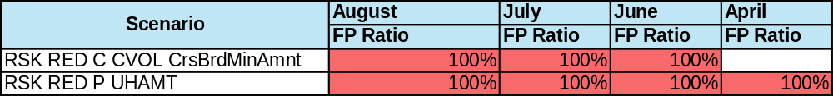

Rationale:
Removing poor performing fraud detection rules is crucial for maintaining the overall balance and efficiency of a fraud detection system. These rules, if not regularly reviewed and optimized, can lead to an excessive number of false positives, which not only burden customer service teams with unnecessary investigations but also erode customer trust by flagging legitimate transactions as fraudulent. Moreover, ineffective rules can dilute the focus of the system, making it harder to detect genuine fraudulent activities that might slip through due to the noise created by irrelevant alerts. By systematically identifying and eliminating underperforming rules, we can streamline our fraud detection process, enhance the accuracy of our system, and ensure that resources are directed towards more relevant or risky alerts. This not only improves operational efficiency but also strengthens the overall integrity and reliability of the fraud prevention framework.
RSK RED P UHAMT
Over the past four months, the RSK RED P UHAMT rule has not identified any actual instances of fraud. Instead, it has only generated false positives, leading to unnecessary disruptions in legitimate transactions and a worse customer experience. The rule was originally added in Jan 2026 and since then a considerable number of newer/better rules have been added.
Scenario | July | June | May | April
Scenario | FP Ratio | FP Ratio | FP Ratio | FP Ratio
RSK RED P UHAMT | 100% | 100% | 100% | 100%

Given the nature of the rule, which triggers on payments exceeding £10,000 from a private account user who has already made at least one payment to the same new and unknown beneficiary in 24 hours on the first 2 days of usage, it appears that the criteria set may be too stringent or misaligned with typical customer behaviour. In many cases, private customers might reasonably need to make multiple payments to a new beneficiary on the first day of their relationship. We often see examples of this where customers are doing separate payments for separate investments or moving funds in chunks to new accounts (see examples below).
Figure 1.1 – Customer moving funds for investments (each payments has different ref) all in same day.
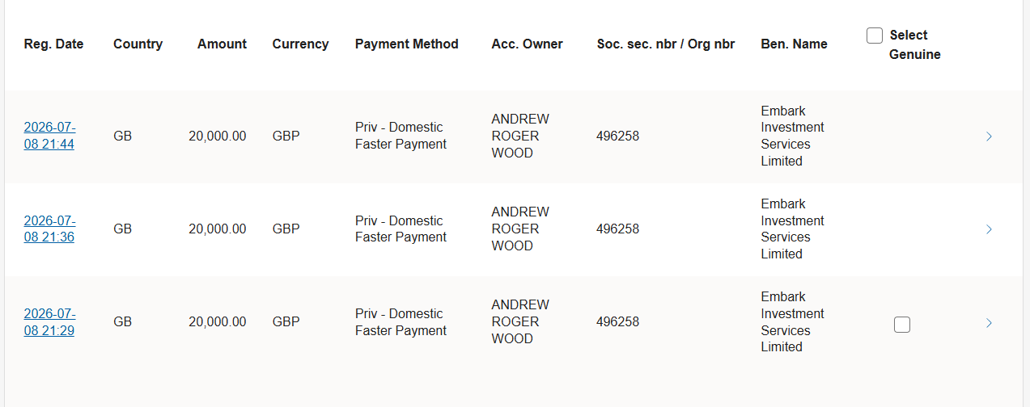

Figure 1.2 – Customer moving funds to same bene account via several payments 1 after another in a 24hour period.
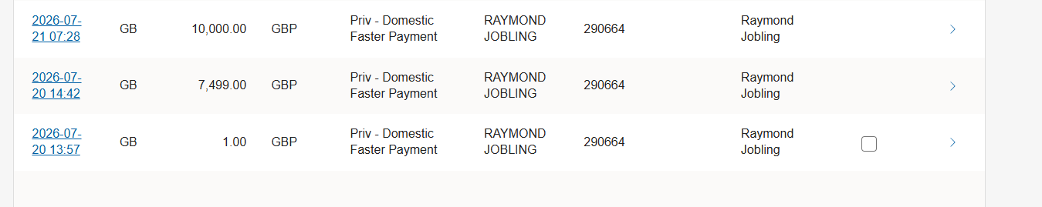
While the intent behind the rule is well-founded—recognizing that fraudsters often attempt to move funds quickly—the current implementation seems to disproportionately affect genuine transactions. Moreover, the rule operates in conjunction with other RSK RED scenarios, which collectively aim to mitigate fraud risks. This can be seen in the below data where approx. 75% of false positive alerts on RSK RED P UHAMT also alert on a separate or alternative scenarios, the most common other scenarios can be seen below:
Scenario | Hits
RSK RED P UHAMT | 194
RSK RED P NBG Limit FP | 91
RSK NBG Limit P FP | 75
RSK RED P UVAL GEN | 69
ABNM RSK P HAmntDev | 66
RSK RED P CVAL | 66
ABNM RSK PC D1 | 53
RSK RED P CVOL CVAL | 34
RSK RED P CVOL | 22
RSK RED P UVOL GEN | 16

Considering these factors, it is sensible to reassess the necessity of this rule. If the goal is to maintain robust fraud prevention measures while minimizing false positives then this rule shows/offers no detection value for considerable friction and what is it adding.
The rule will be kept live for OOH periods (10pm – 9am) but again the question could be raised on what value it adds, a phased implementation approach of setting this rule to be OOH for now to some reduction in hours while allowing us to continue to monitor if it adds value but given the 4 months of data we now have on this rule how much longer should it be assessed for before a decision can be made.
RSK RED C CVOL CrsBrdMinAmnt
To improve the performance of the RSK RED C CVOL CrsBrdMinAmnt scenario, we propose adding a £10k materiality factor to the existing scenario. This scenario was originally added as wider MO coverage following a fraud method of using low value chaps to avoid hold rules by being below the min amount. The scenario for cross border was added to add theoretical coverage in case we saw the attack spread to this mythology. Since then the min amount for Crop cross border has been dropped to 0.96p such that nearly all payments are in scope of the rules (99.94%) and as such this gap is not a option any more, however the rule was kept in place to cover the potential risk of low value cross borders being exploited by fraudsters.
This adjustment will trigger an alert when more than five payments are made to new beneficiaries within a four-hour window, with each payment between £0 and approximately £5k, and the total cumulative value exceeding £10k. Additionally, this rule will only be active for new beneficiary days less than two and where fewer than two authorisers are involved in the payment process.
This enhancement will improve our ability to detect sophisticated fraudulent activities by considering the collective impact of multiple small transactions. For instance, if the overall collective impact remains low (sub £10k for corporations), we will choose not to alert. £10K was selected to minimize disruptions to legitimate transactions while still maintaining a level of fraud protection. In most other cases we would historic fraud pattern to set this threshold but given the pattern this rule is detecting hasn’t occurred this couldn’t be done.
This approach will reduce false positives by filtering out high volume low value payments where the overall value remains low. I.e high volumes to new benes could be fraud but if the total aggregate value was only £1250 then the overall fraud impact is low, but if the high volumes to new benes are fraud and the aggregate values to new bene’s is already greater than £10K the impact is higher and we would not want to allow this activity to continue without a review. An example of the former behaviour is the below magazine publishing company that frequently trigger this rule.
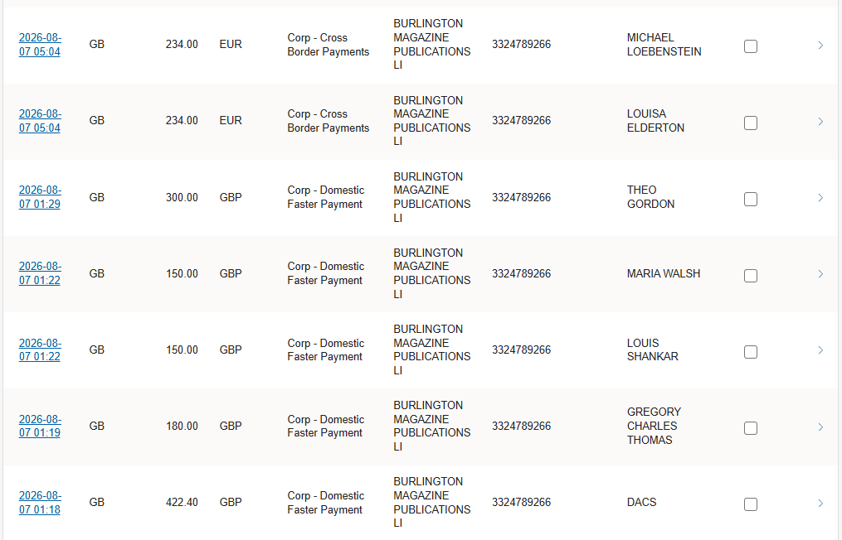
Consequently, this change will minimize unnecessary alerts and allow our team to focus on genuine suspicious activities or situations where the aggregate impact has increased to a point where intervention is necessary. Furthermore in the previous 6 months the Corp cross border fraud seen has all been single payment examples and value far higher than this scenario covers and hence are not in-scope of this scenario, additionally this scenario has not detected any fraud in the approx. 2.5 months it has now been active. Therefore known fraud detection levels are not impacted by this change, it is simply making the rule more proportional to what we see in terms of day to day activity.
Scenario | August | July | June
Scenario | FP Ratio | FP Ratio | FP Ratio
RSK RED C CVOL CrsBrdMinAmnt | 100% | 100% | 100%
Given the narrow scope of this rule (we typically don’t target low value payment unless we see clear trends/patterns that need interrupting) crossover hits are much lower (Avg 19%) than we see in other scenarios however in this adjustment we are only moving the scenario to alerting later/once another trigger is met as opposed to removing control entirely.
Date | Target_hit | Other_hit | % Other Hit
10/08/2026 | 1 | 1 | 100%
07/08/2026 | 3 | 0 | 0%
06/08/2026 | 2 | 0 | 0%
05/08/2026 | 2 | 0 | 0%
04/08/2026 | 1 | 0 | 0%
31/07/2026 | 19 | 7 | 37%
30/07/2026 | 3 | 0 | 0%
29/07/2026 | 1 | 1 | 100%
27/07/2026 | 8 | 2 | 25%
17/07/2026 | 4 | 0 | 0%
13/07/2026 | 1 | 0 | 0%
10/07/2026 | 4 | 0 | 0%
03/07/2026 | 4 | 0 | 0%
02/07/2026 | 2 | 0 | 0%

The £10k threshold caps potential losses at a manageable level and was chosen as a compromise between managing fraud losses and impact genuine customers. However, this limit may be adjusted or reduced if we observe fraudsters exploiting these limits. Note – however previous 6 month cross border fraud seen has all been single payment examples.

Change Impact Summary:
False positive reduction is simulated to be between 1-5 per day on Priv Fasters and then less than 1 per day CHAPS/CrossBorder for the RSK RED P UHAMT adjustment (simulated across 5th-7th of August).
False positive reduction is simulated to be 1-2 per day due to the RSK RED C CVOL CrsBrdMinAmnt adjustment (simulated across 5th-7th of August).
All simulations contains variability due to how simulations work, ongoing action to create a post change validation process to assess simulation vs real outcomes of changes.

Scenario’s in control set:
Old: NIFA07-2026-08-10-11.52
New: NIFA07-2026-08-10-10.19

Link to new Scenario Proposals
Updated proposals –
\\shbmain\data\London\Resources\N-Z\UKX FCP Shared Data\FCDA-ROVA Tfr\ROVA Governance\Change Governance\Scenario Proposals & Controlset Validation\NIFA07-2026-08-10-10.19\RSK RED C CVOL CrsBrdMinAmnt_Proposal_2026-09-15.pdf
\\shbmain\data\London\Resources\N-Z\UKX FCP Shared Data\FCDA-ROVA Tfr\ROVA Governance\Change Governance\Scenario Proposals & Controlset Validation\NIFA07-2026-08-10-10.19\RSK RED P UHAMT_Proposal_2026-09-15.pdf

ROVA Checklist
Scenario’s added, removed or adjusted
(do not list for test or inactive scenarios)

Signoffs and Implementation
Created By | Nick Farmer | Date – 10/08/2026
Controlset UKXD Review | Attended by Josh Young, Thom Parkes | Date – 11/08/2026
Control Validation Report Results | Pass | Link - "\\shbmain\data\London\Resources\N-Z\UKX FCP Shared Data\FCDA-ROVA Tfr\ROVA Governance\Change Governance\Scenario Proposals & Controlset Validation\NIFA07-2026-08-10-10.19\NIFA07-2026-08-10-10.19_Validation_2026-08-10.pdf"
UKXD Thresholds Verified | Josh Young, Thom Parkes | Date – 11/08/2026
Controlset UKXB Review | Attended by Al Cummings | Date – 11/08/2026
CFCPO Approval (For reductions/Optimisation only) | Clare Wilson | Date - 11/08/2026
MLRO Oversight (For reductions/Optimisation only) | Natalie Gill | Date – 12/08/2026
Initiated By | Nick Farmer | Date – 11/08/2026
Copy of Current Controlset Taken | Yes | Date – NIFA07-2026-08-10-11.52
Accepted By | Josh Young, Thom Parkes | Date – 12/08/2026
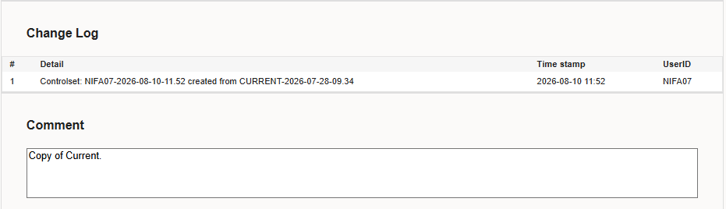

Control Set Changes (from control set change log)
"\\shbmain\data\London\Resources\N-Z\UKX FCP Shared Data\FCDA-ROVA Tfr\ROVA Governance\Change Governance\Control Set Changes\August 2026 Changes\2026-08-12 P UHAMT & C CVOL CrsBrdMinAmnt\NIFA07-2026-08-10-10.19 Change Log.csv"

Simulation Results:
Simulation results for Priv fasters show reductions of 3, 5 and 1 across the 5th,6th and 7th of August. For Priv CHAPS and Cross border 3 days simulations are used due to the lower volumes, within these 3 day sims we see reductions of 1 and 2 respectively. Averaged out we therefore expect to see a reduction of less than 1 per day on these methods but that is expected given the lack of repeated payment to a bene via CHAPS or the overall lower volumes seen on Cross Border.
For Corps Cross Borders simulations show reductions of 2, 2 and 1 across the 5th,6th and 7th of August.

Simulation screenshots below:
Priv Fasters
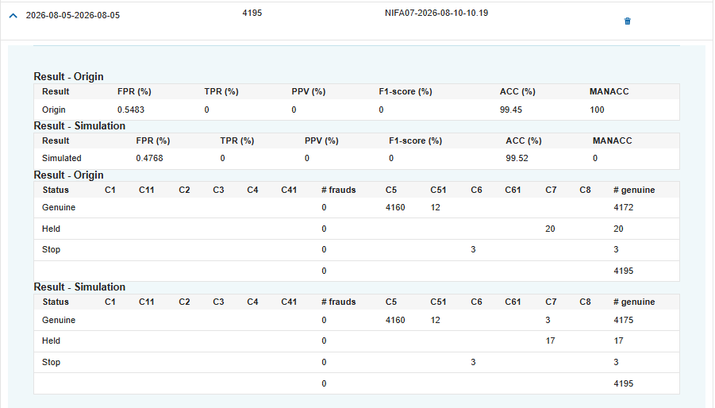
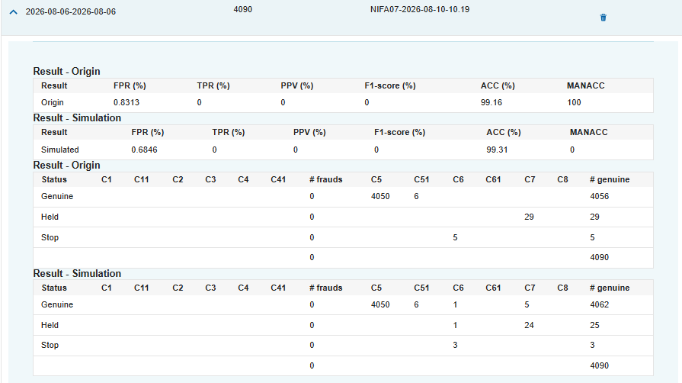
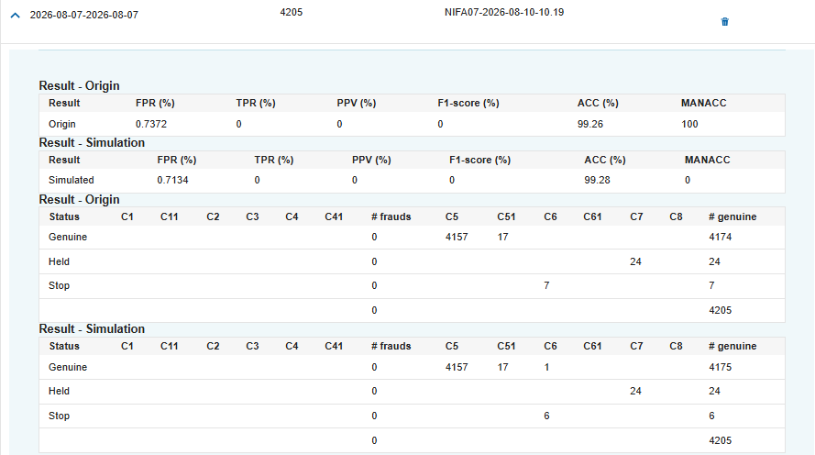
Priv CHAPS
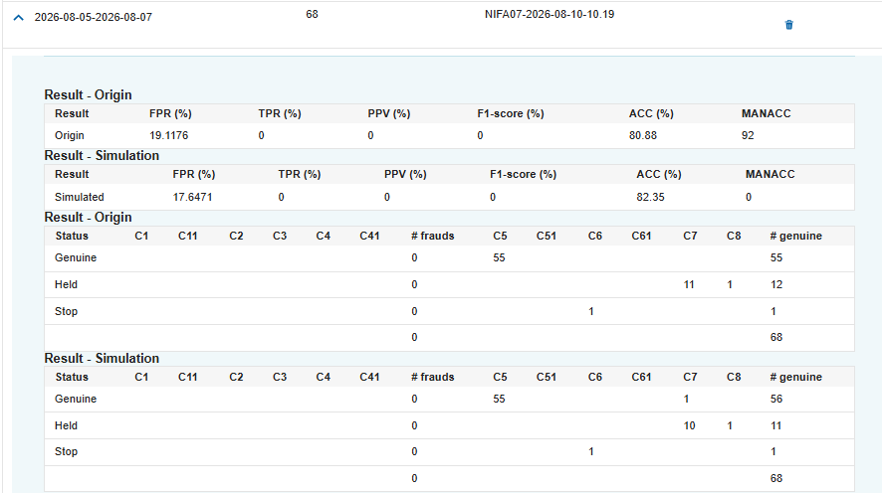
Priv CrossBorder
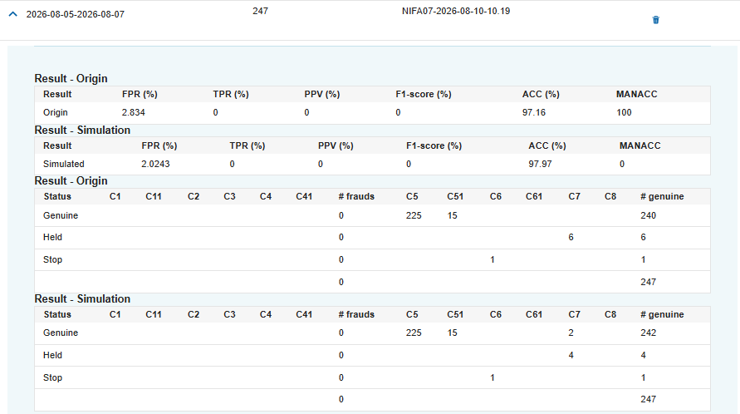
Corp CrossBorder
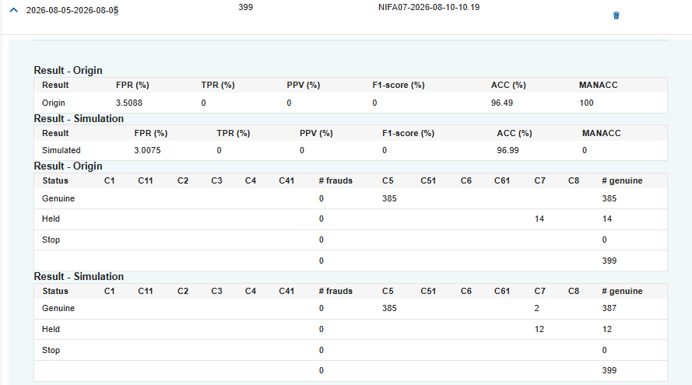
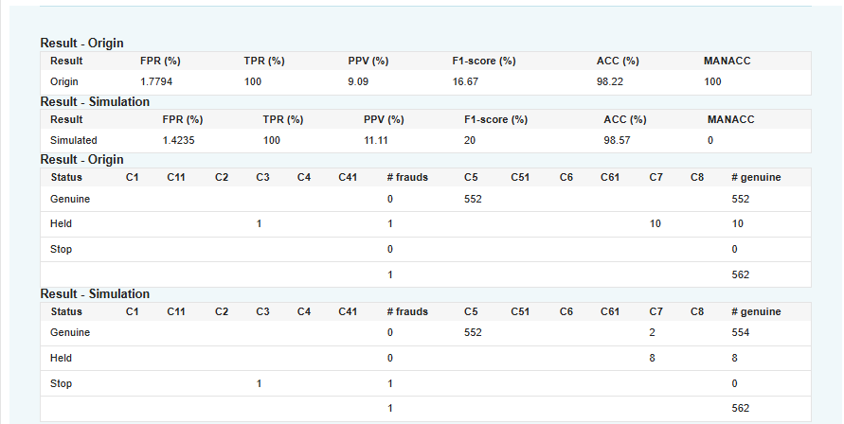
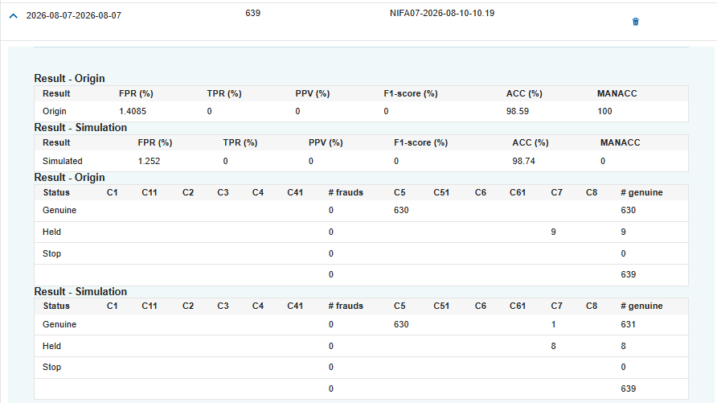

Appendix:

Table showing FPR by scenario for August, July and June.
